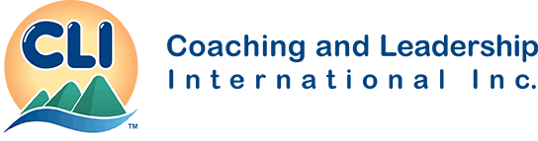

Application to Become a CLI-Facilitator

Thank you for your interest in becoming a CLI-Facilitator which is a very noble position within CLI- Global. You will be given much responsibility to ensure the messages within the training programs are delivered with integrity.

There is a three step process to begin your position as a CLI-Facilitator:

Step 1: Email this Application Form to CLI Co-President, Betska K-Burr, Head of Training, Research and Development at Betska@CoachingandLeadership.com.

Step 2: Immediately upon approval of your Application, CLI-Global will direct you where to make payment.

Step 3: CLI-Global will forward your Facilitator Package to you. Training will either be live training or recorded training depending upon your date of entry into the program.
_______________________________ ________________________________

Conditions for Approval of Application:

To be great as a Facitator you must love people and wish to serve them whole-heartedly. CLI provides you with program training and you are expected to acquire facilitation skills on your own.

Only Enhanced Licensees receive the privilege of having access to new products and programs.

You have the required prerequisite training from CLI. Example: To deliver the Leader as Power Coach® you need Certified Power Coach® level training.
_______________________________ ________________________________

Personal Details: (Please TYPE your responses. Hand-written applications not accepted)

I am applying to become a CLI Facilitator of: □ Leader as Power Coach® □ The Brain Walk®

First Name: __________________________ Family Name: _____________________________

Date of Birth [day/month/year]: __________________ □ Female □ Male

Organization: __________________________________________ Title: _______________________

Mailing Address: __________________________________________________________________________________

Prov/State: ____________________ Country: _______________________ Postal/Zip Code: _______________

Work Phone: ( ) _________________ Cell Phone: ( )______________________

Skype id: ______________________ Email Address: ___________________________________________

CLI Training and Certifications: Check all that you have achieved

□ My Enhanced Licensed is paid and is up-to-date.

□ APC: I have written and passed my Associate Power Coach® Knowledge Assessment.

□ CPC: I have my CPC level training.

□ CPC certification: I have passed both my written and oral CPC exams.

□ CGPC: I have studied the Certified Group Power Coach® Program.

□ CEPC: I have completed my Certified Executive Power Coach® training with attendance of at least 85% of classes.

□ SCPC: I have completed my SCPC level taining.

□ PCPC: I have passed both my written and oral PCPC exams.

Short Bio: (Maximum 200 words in bullet points or one page resume may be attached.)

Describe how much facilitation experience you have: (Maximum 100 words)

What is your intention? Provide a summary of your Business Plan to sell and deliver the Facilitation Program of your choice? (Maximum 100 words)

Thank you for your Application. We’ll be in touch soon.

